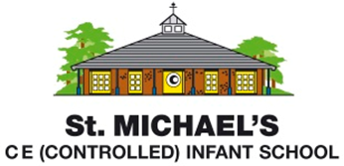
Statement of Intent for Computing
We recognise that computing has a unique place within our curriculum, equipping our children with the skills in computer science, information technology and digital literacy that they will need to participate fully within our increasingly digital world. We are also mindful of the fact that, outside of the school environment, many of our children are voracious consumers of technology at the expense of time spent outdoors, being physically active or being imaginative.
With this in mind, at St. Michael’s we aim to broaden children’s experiences of technology, so that they move beyond being passive consumers and develop the knowledge and skills they need to become innovators, problem-solvers and communicators with technology instead. This focus is underpinned by our school values of creativity and perseverance.
As part of our vital safeguarding role, we spend time at the beginning of each half term teaching children how to use technology safely and we also share this learning with parents to ensure that children develop confidence and automaticity in staying safe online at home and at school.

