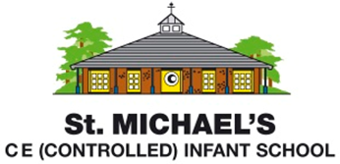
Statement of Intent for Design and Technology

At St. Michael’s, Design and Technology links to our school vision through the values of creativity and perseverance. Through teaching and learning in Design and Technology, we aim to:
- provide children with rich opportunities to create a product for a purpose or to solve a problem
- stimulate children’s creativity and independent thought
- give children a working understanding of the design process, from the planning stage to the final evaluation
- develop children’s resilience to persevere when their design isn’t successful the first time
- deepen children’s technical knowledge over time so that they are able to achieve greater success and accuracy

At our school, learning through play and discovery is the starting point for design and technology. Where possible, the purpose for Design and Technology links to learning in other curriculum areas. For example, in Year 2, after studying different versions of ‘Little Red Riding Hood’ in English, the children design a new bed for Grandma as part of their learning about freestanding structures.
The children are specifically taught the key vocabulary linked to each D.T. unit so that they are able to communicate their ideas and evaluate products coherently and precisely. We recognise that within our community there is also a need to promote a healthy lifestyle and the food and nutrition aspect of this subject provides a valuable context for this, so this is covered in every year group.

