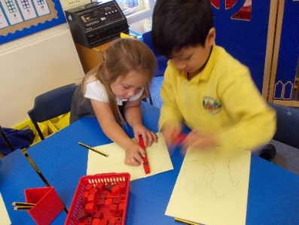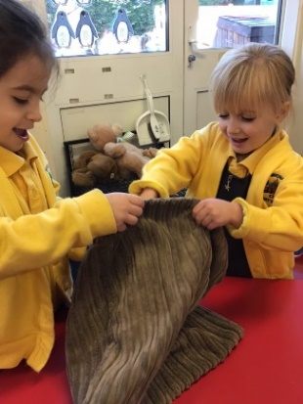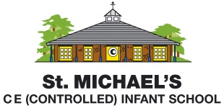

**St Michael’s Infant School**

**Our Learning Charter**

**At St Michael’s Infant School, We Aspire For All Of Our Children To:**

1. **Live out our Christian values of love, forgiveness, friendship, truthfulness, perseverance and creativity.**
2. **Be capable and confident communicators**
3. **Be independent Learners**
4. **Know their self- worth**
5. **Recognise their talents and know that they can make a positive contribution**
6. **Be enthusiastic and competent readers**
7. **Be secure enough in their writing ability that they can effectively express their ideas and thoughts**
8. **Be numerically fluent and use this fluency to apply to real life problems**
9. **Be curious about the world around them and ask questions**
10. **Use their imaginations and creativity**
11. **Persevere and keep on trying even when the learning is challenging**

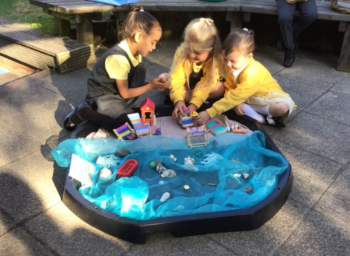

**Our Core Learning Principles:**

* **We are all lifelong learners and always learning**
* **Diversity is celebrated in our school**
* **Parents and families are partners in education**
* **Quality learning happens when learners are challenged and engaged**
* **We believe that using story is key to developing the imagination, language and communication skills of our children**
* **We try to create learning experiences that connect with real life, purpose and problem solving**
* **We have high expectations for all learners**
* **We learn best by learning together**
* **When possible, learning is personalised to an individual’s needs**
* **Learners develop the skills, knowledge and understanding to be confident future global citizens**