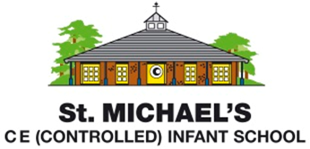
Statement of Intent for Personal, Social and Health Education
Through our Personal, Social and Health Education (PSHE) lessons at St Michael’s, we want to encourage all children to be unique, positive, and mindful individuals. PSHE forms an integral part of the curriculum at our school. Weekly lessons are planned and taught with the aim of giving pupils the knowledge, skills and understanding they need to lead confident, healthy, independent lives and to become informed, active, responsible citizens. Through the underpinning provided by our PSHE curriculum, we are committed to encouraging the children to develop an understanding of right and wrong and to take responsibility for their own behaviour. Alongside these over-arching aims, we also seek to reinforce our Christian Values of love, truthfulness, perseverance, forgiveness, creativity and friendship. We will achieve these aims by engaging children in discussions which challenge their thinking, encourage reflection and ultimately, help them develop the understanding that their actions and choices play a significant part in the success of our school and wider community.

To fulfil National Curriculum requirements and our school aims, we have chosen to use the ‘Jigsaw’ scheme as a basis for our PHSE teaching and learning. Jigsaw, the mindful approach to PSHE, is a progressive and spiral scheme of learning. In planning the lessons, Jigsaw PSHE ensures that learning from previous years is revisited and extended, adding new concepts, knowledge and skills, year on year as appropriate. The table below draws out the spiral knowledge and skills progression within all six Puzzles (units of work) including the key vocabulary used in each year group; explicit links to the DfE statutory Relationships and Health Education outcomes have been made in each Puzzle.

With strong emphasis on emotional literacy, building resilience and nurturing mental and physical health, Jigsaw enables us to deliver engaging and relevant PSHE within a whole-school approach. Jigsaw lessons also include mindfulness allowing children to advance their emotional awareness, concentration and focus.

