English Long-term Curriculum Planning
 | Autumn 1 | Autumn 2 | Spring 1 | Spring 2 | Summer 1 | Summer 2
Reception | 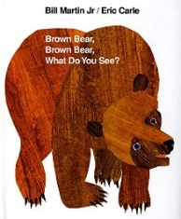  Outcome 1:  Oral retelling using a shared story map  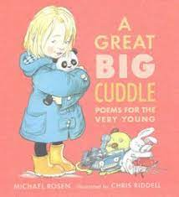  Outcome 2:  Video of poem recital with actions | 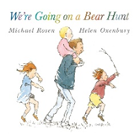  Outcome 1:  Create a simple story map with initial sound labels to support oral retelling  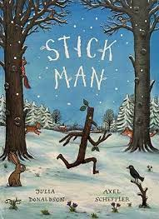  Outcome 2:  Write a Christmas list of CVC items | 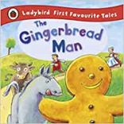  Outcome 1:  Create a simple story map with CVC labels to support oral retelling  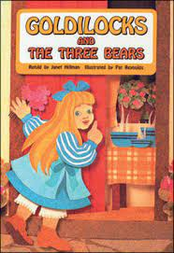  Outcome 2:  Write simple CVC captions for pictures | 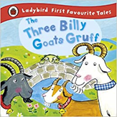  Outcome 1:  Write a simple sentence to caption a photo of the farm visit  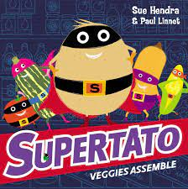  Outcome 2:  Create an ‘I can’ book using simple patterned sentences | 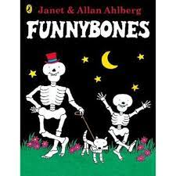  Outcome 1:  Write simple recount sentences to caption a photo of the school trip  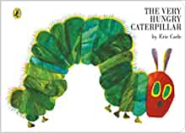  Outcome 2:  Create a simple wanted poster for the Very Hungry Caterpillar  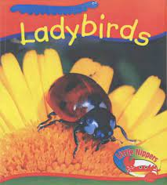  Outcome 2:  Write simple sentences to describe ‘What’s under the leaf? | 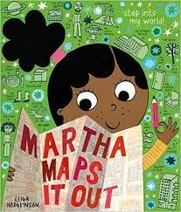  Outcome 1:  Create a map of the class garden with labels for features  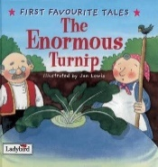  Outcome 2:  Write simple instructions for planting cress  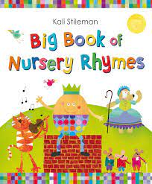  Outcome 3:  Create puppets to support oral recital
Year 1 | 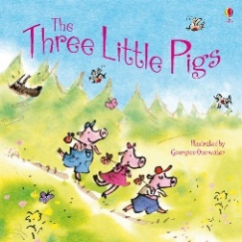  Outcome 1:  Label a map of the story– sequenced retelling  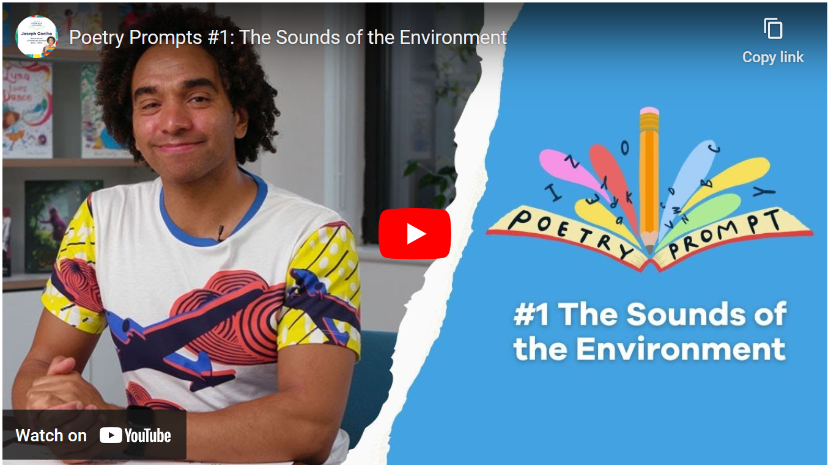  Outcome 2:  Create poetic phrases to add to a class poem based on the structure of ‘From my Window’ | 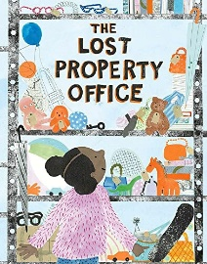  Outcome 1:  Write a list of lost toys  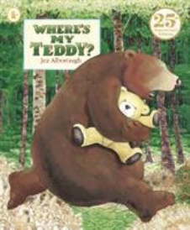  Outcome 2:  Create a poster describing a lost toy | 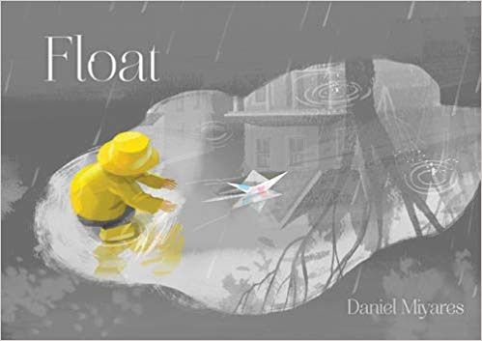  Outcome 2:  Create a simple past tense narrative to accompany the pictures  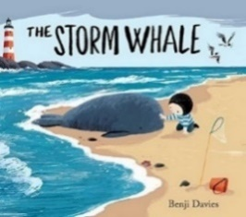  Outcome 2:  Write a short past tense narrative based on the text | 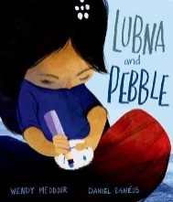  Outcome 1:  Write a thank you letter in role as a character  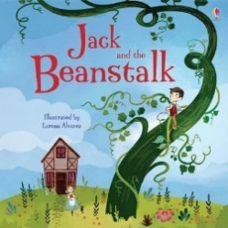  Outcome 2:  Create a warning poster describing the giant | 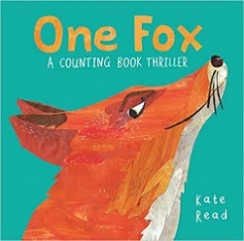  Outcome 1:  Write a counting poem about an animal, following the structure of the poetic text  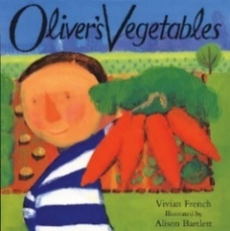  Outcome 2:  Write a letter in role recounting Oliver’s week | 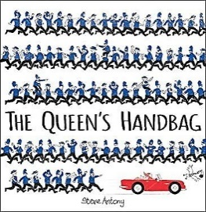  Outcome 1:  Write instructions for making a crown  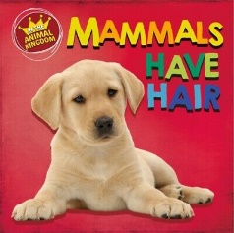  Outcome 2:  Write a similar information page about birds
Year 2 | 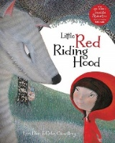  Outcome 1:  Character Description  In the form of a wanted poster for the wolf  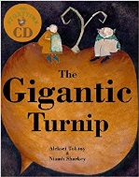  Outcome 2  Innovated Narrative | Pie Corbett How to Trap a Dragon  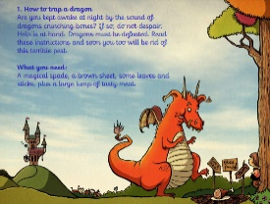  Outcome 1:  Instructions how to catch a wolf  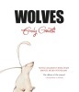  Outcome 2  Non-Chronological Report about wolves | 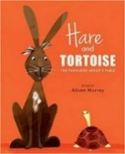  Outcome 1:  Recount  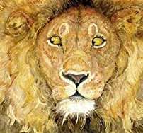  Outcome 2  Write a fable in own words to sit alongside a wordless picture book | 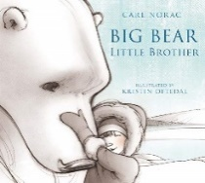  Outcome 1:  Diary in role as a character  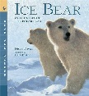  Outcome 2  Information text presented as a leaflet/information page | 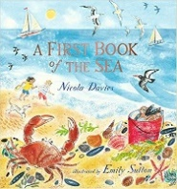  Outcome 1:  Different forms of poetry  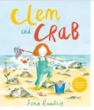  Outcome 2  Persuasive Letter to clean up the beach | 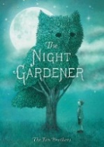  Outcome 1:  Description of the topiaries  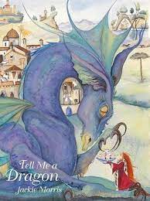  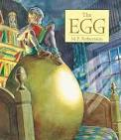  Outcome 2:  Innovated narrative

