English Long-term Curriculum Planning
 | Autumn 1 | Autumn 2 | Spring 1 | Spring 2 | Summer 1 | Summer 2
Reception | 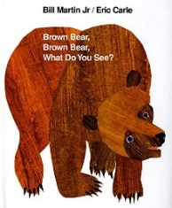  Outcome 1:  Oral retelling using a shared story map  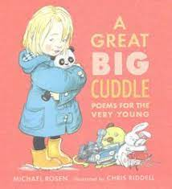  Outcome 2:  Video of poem recital with actions | 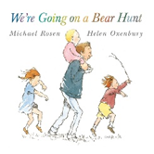  Outcome 1:  Create a simple story map with initial sound labels to support oral retelling  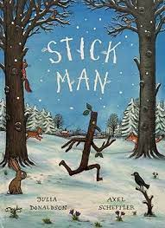  Outcome 2:  Write a Christmas list of CVC items | 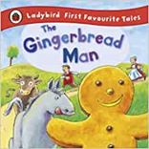  Outcome 1:  Create a simple story map with CVC labels to support oral retelling  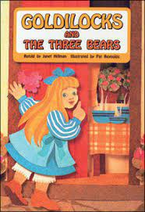  Outcome 2:  Write simple CVC captions for pictures | 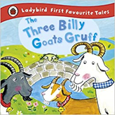  Outcome 1:  Write a simple sentence to caption a photo of the farm visit  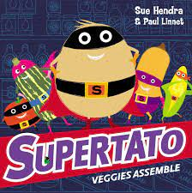  Outcome 2:  Create an ‘I can’ book using simple patterned sentences | 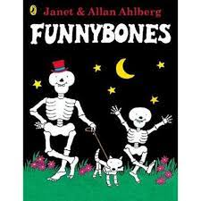  Outcome 1:  Write simple recount sentences to caption a photo of the school trip  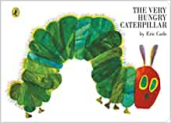  Outcome 2:  Create a simple wanted poster for the Very Hungry Caterpillar  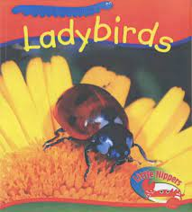  Outcome 2:  Write simple sentences to describe ‘What’s under the leaf? | 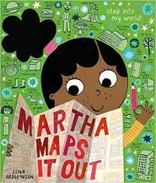  Outcome 1:  Create a map of the class garden with labels for features  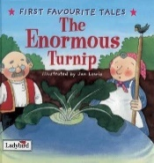  Outcome 2:  Write simple instructions for planting cress  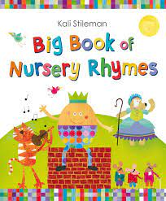  Outcome 3:  Create puppets to support oral recital
Year 1 | 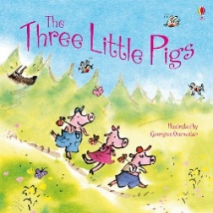  Outcome 1:  Label a map of the story– sequenced retelling  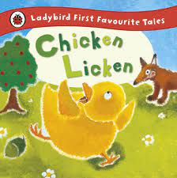  Outcome 2:  Create a story sack to support oral retelling | 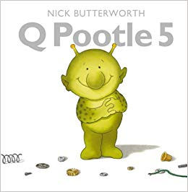  Outcome 1:  Write a list of items for the alien  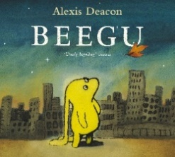  Outcome 2:  Write letters and postcards in role as the characters | 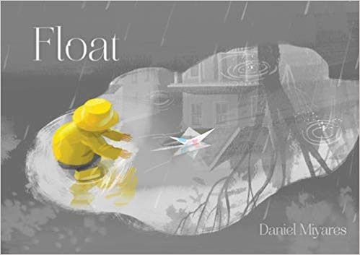  Outcome 1:  Write instructions on how to make a paper boat  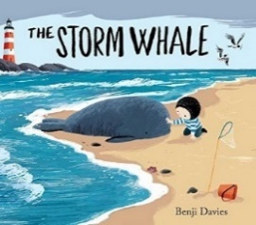  Outcome 2:  Write a short narrative based on the text | 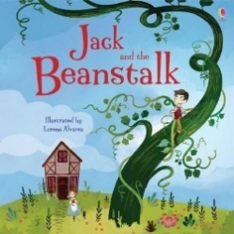  Outcome 1:  Write a description of the giant  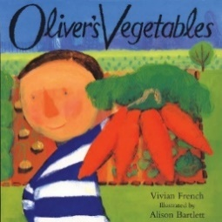  Outcome 2:  Write a recount of Oliver’s week | 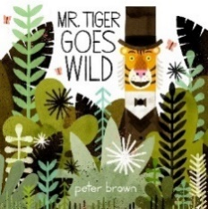  Outcome 1:  Write a letter in role as the tiger to persuade the other characters to ‘go wild’  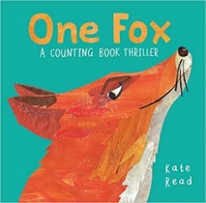  Outcome 2:  Write a counting poem about an animal, following the structure of the poetic text | 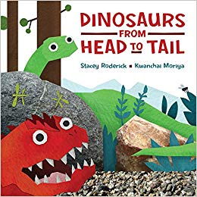  Outcome 1:  Write an information page about a dinosaur  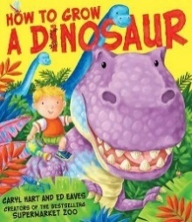  Outcome 2:  Write a recount of Albie’s experiences
Year 2 | 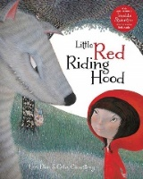  Outcome 1:  Character Description  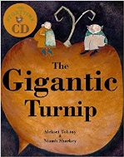  Outcome 2  Innovated Narrative | 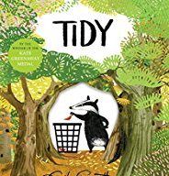  Outcome 1:  Persuasive Letter  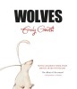  Outcome 2  Non-Chronological Report | 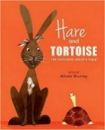  Outcome 1:  Recount  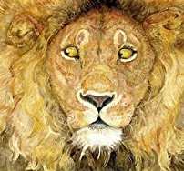  Outcome 2  Write a fable in own words to sit alongside a wordless picture book | 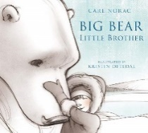  Outcome 1:  Diary in role as a character  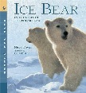  Outcome 2  Information text presented as a leaflet/information page | 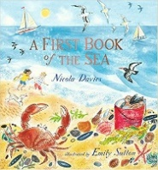  Outcome 1:  Different forms of poetry  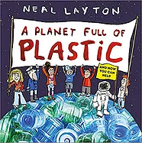  Outcome 2  Class campaign to reduce plastic | 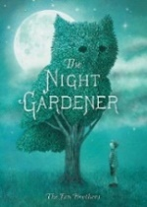  Outcome 1:  Description of the topiaries  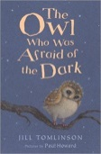  Outcome 2  Innovated version of the story for another animal

