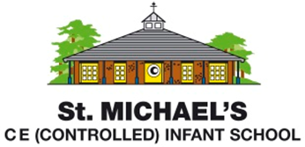
Statement of Intent for English
Through our English teaching at St. Michael’s Infant School, we intend to:
- provide children with a broad, balanced and challenging English curriculum
- embark on an exciting journey that supports and develops children’s speaking, listening, reading and writing skills across the curriculum
- develop children to become confident speakers who initiate and engage in discussions with others
- equip children with the necessary skills required to become capable and fluent readers, thus providing a lifelong love of reading and literature
- immerse children in a rich variety of texts which will inspire their imagination
- inspire children to write clearly and accurately for a range of contexts, purposes and audiences by developing their vocabulary
- prepare the children to use and apply their English skills, which are essential to become successful learners at school and in the world beyond

We have chosen to use the Hampshire Learning Journey Model to structure our planning, as we recognise that this covers a range of genres and reading is explicitly linked to writing. It provides clear models of developmental progression and high quality texts are used to enrich the children’s language and vocabulary development. At St Michael’s, we believe that all our children can become fluent readers and writers. This is why we teach reading through Little Wandle Letters and Sounds Revised, which is a systematic and synthetic phonics programme. As a result, all our children are able to tackle any unfamiliar words as they read. We also model the application of the alphabetic code through phonics in shared reading and writing, both inside and outside of the phonics lesson and across the curriculum. We have a strong focus on language development for our children because we know that speaking and listening are crucial skills for reading and writing in all subjects.

